LAB TASK #03

Name: Naqeebullah
Roll No.: 25P-0660
Section: BCS-1B
Lab Instructor: Sir Behram Shah
QUESTION.NO.01:
#include<stdio.h>
int main()
{
int w,a,x;
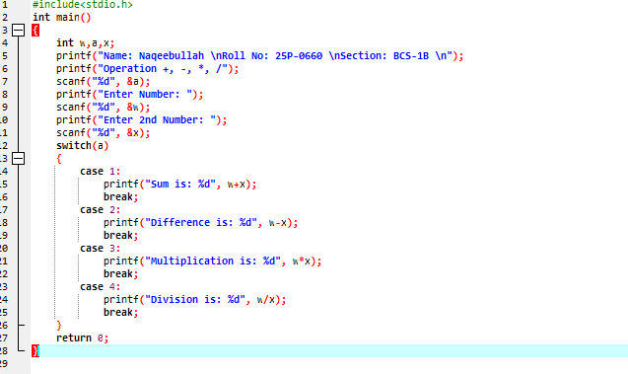
printf("Name: Naqeebullah \nRoll No: 25P-0660 \nSection: BCS-1B \n");
printf("Operation +, -, *, /");
scanf("%d", &a);
printf("Enter Number: ");
scanf("%d", &w);
printf("Enter 2nd Number: ");
scanf("%d", &x);
switch(a)
{
case 1:
printf("Sum is: %d", w+x);
break;
case 2:
printf("Difference is: %d", w-x);
break;
case 3:
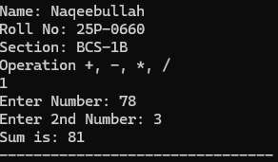
printf("Multiplication is: %d", w*x);
break;
case 4:
printf("Division is: %d", w/x);
break;
}
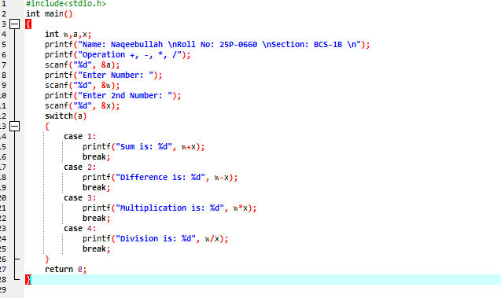
return 0; }
QUESTION.NO.02:
#include<stdio.h>
int main()
{
float a, m, n, x, y;
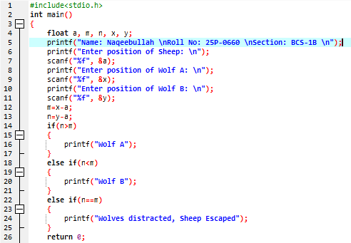
printf("Name: Naqeebullah \nRoll No: 25P-0660 \nSection: BCS-1B \n");
printf("Enter position of Sheep: \n");
scanf("%f", &a);
printf("Enter position of Wolf A: \n");
scanf("%f", &x);
printf("Enter position of Wolf B: \n");
scanf("%f", &y);
m=x-a;
n=y-a;
if(n>m)
{
printf("Wolf A");
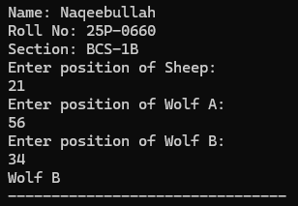
}
else if(n<m)
{
printf("Wolf B");
}
else if(n==m)
{
printf("Wolves distracted, Sheep Escaped");
}
return 0;
}

QUESTION.NO.03:
#include<stdio.h>
int main()
{
float a, b, c, d, x;
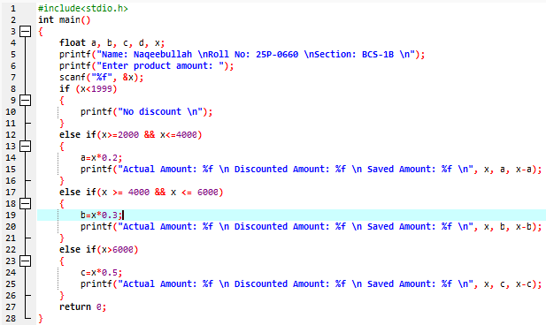
printf("Name: Naqeebullah \nRoll No: 25P-0660 \nSection: BCS-1B \n");
printf("Enter product amount: ");
scanf("%f", &x);
if (x<1999)
{
printf("No discount \n");
}
else if(x>=2000 && x<=4000)
{
a=x*0.2;
printf("Actual Amount: %f \n Discounted Amount: %f \n Saved Amount: %f \n", x, a, x-a);
}
else if(x >= 4000 && x <= 6000)
{
b=x*0.3;
printf("Actual Amount: %f \n Discounted Amount: %f \n Saved Amount: %f \n", x, b, x-b);
}
else if(x>6000)
{
c=x*0.5;
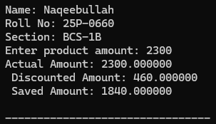
printf("Actual Amount: %f \n Discounted Amount: %f \n Saved Amount: %f \n", x, c, x-c);
}
return 0;
}

QUESTION.NO.04:
#include<stdio.h>
int main()
{
float fsc, nts;
printf("Name: Naqeebullah \nRoll No: 25P-0660 \nSection: BCS-1B \n");
printf("Enter FSC Marks: \n");
scanf("%f", &fsc);
printf("Enter NTS Marks: \n");
scanf("%f", &nts);
if(fsc>70)
{
if(nts>70){
printf("Eligible for It in Oxford University");
}
else if(nts>=60){
printf("Eligible for Electronics in Oxford University");
}
else if(nts>=50){
printf("Eligible for Telecommunication in Oxford University");
}
}
if(nts>=50)
{
if(fsc >= 60 && fsc <= 70){
printf("Eligible for IT in MIT");
}
else if(fsc >= 50 && fsc <= 59){
printf("Eligible for Chemical in MIT");
}
else if(fsc<50 && fsc>=40){
printf("Eligible for Computer in MIT");
}
}
return 0;
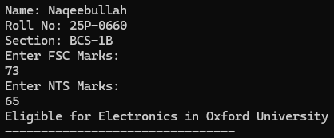
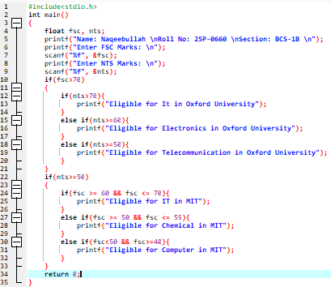

QUESTION.NO.05:
#include <stdio.h>
int main()
{
char coffeeType;
int isDouble, isManual;
printf("Name: Naqeebullah \nRollno: 25P-0660 \nSection: BCS-1B\n");
printf("Enter Coffee Type (W = White, B = Black):\n");
scanf("%c", &coffeeType);

printf("Is cup size double? (1 for yes, 0 for no): \n");
scanf("%d", &isDouble);

printf("Is coffee manual? (1 for yes, 0 for no):\n");
scanf("%d", &isManual);

printf("Coffee Preparation Steps\n");

switch(coffeeType) {

case 'W':
case 'w':
printf("Put Water: %d mins\n",15, isDouble);
printf("Add Sugar: %d mins\n",15, isDouble);
printf("Mix Well: %d mins\n",20, isDouble);
printf("Add Coffee: %d mins\n",2, isDouble);
printf("Add Milk: %d mins\n",4, isDouble);
printf("Mix Well: %d mins\n",20, isDouble);
printf("The total time is: 1 hour and 16 minute");
break;

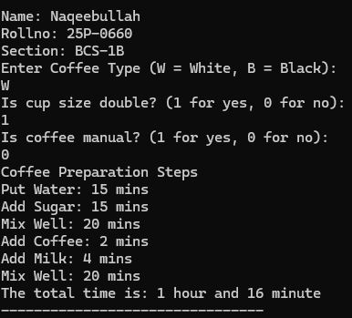
case 'B':
case 'b':
printf("Put Water: %d mins\n",20, isDouble);
printf("Add Sugar: %d mins\n",20, isDouble);
printf("Mix Well: %d mins\n",25, isDouble);
printf("Add Coffee: %d mins\n",15, isDouble);
printf("Mix Well: %d mins\n",25, isDouble);
printf("The total time is: 1 hour and 45 minute ");
break;

default:
printf("Invalid coffee type!\n");
}
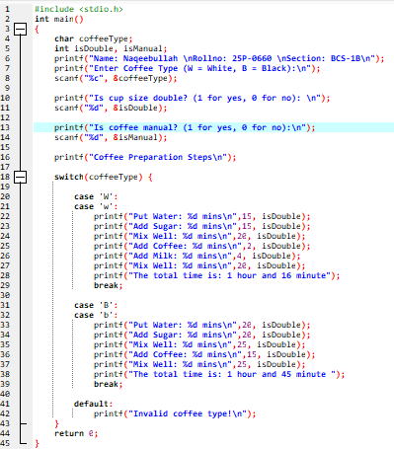
return 0;
}

QUESTION.NO.06:
CODE’S SCREENSHOT IS NOT ATTACHED DUE TO LONG SIZE CODE
#include<stdio.h>
int main()
{
printf("WELCOME TO ZU RESTOURANT ONLINE ORDER PLACEMENT \nSelect from following menu\n");
int n, qty;
char choice;
int total = 0;

printf("B = Burger (Rs.200)\n");
printf("F = French Fries (Rs.50)\n");
printf("P = Pizza (Rs.500)\n");
printf("S = Sandwiches (Rs.150)\n");

printf("\nEnter number of types of snacks you want to order (2, 3 or 4): ");
scanf("%d", &n);

if (n == 2) {
printf("\nEnter choice for snack 1 (B/F/P/S): ");
scanf(" %c", &choice);
printf("Enter quantity: ");
scanf("%d", &qty);

switch (choice) {
case 'B': case 'b': total += 200 * qty;
break;
case 'F': case 'f': total += 50 * qty;
break;
case 'P': case 'p': total += 500 * qty;
break;
case 'S': case 's': total += 150 * qty;
break;
default: printf("Invalid choice!\n");
}

printf("\nEnter choice for snack 2 (B/F/P/S): ");
scanf(" %c", &choice);
printf("Enter quantity: ");
scanf("%d", &qty);

switch (choice) {
case 'B': case 'b': total += 200 * qty;
break;
case 'F': case 'f': total += 50 * qty;
break;
case 'P': case 'p': total += 500 * qty;
break;
case 'S': case 's': total += 150 * qty;
break;
default: printf("Invalid choice!\n");
}
}
else if (n == 3) {

printf("\nEnter choice for snack 1 (B/F/P/S): ");
scanf(" %c", &choice);
printf("Enter quantity: ");
scanf("%d", &qty);

switch (choice) {
case 'B': case 'b': total += 200 * qty;
break;
case 'F': case 'f': total += 50 * qty;
break;
case 'P': case 'p': total += 500 * qty;
break;
case 'S': case 's': total += 150 * qty;
break;
default: printf("Invalid choice!\n");
}

printf("\nEnter choice for snack 2 (B/F/P/S): ");
scanf(" %c", &choice);
printf("Enter quantity: ");
scanf("%d", &qty);

switch (choice) {
case 'B': case 'b': total += 200 * qty;
break;
case 'F': case 'f': total += 50 * qty;
break;
case 'P': case 'p': total += 500 * qty;
break;
case 'S': case 's': total += 150 * qty;
break;
default: printf("Invalid choice!\n");
}

printf("\nEnter choice for snack 3 (B/F/P/S): ");
scanf(" %c", &choice);
printf("Enter quantity: ");
scanf("%d", &qty);

switch (choice) {
case 'B': case 'b': total += 200 * qty;
break;
case 'F': case 'f': total += 50 * qty;
break;
case 'P': case 'p': total += 500 * qty;
break;
case 'S': case 's': total += 150 * qty;
break;
default: printf("Invalid choice!\n");
}
}
else if (n == 4) {
printf("\nEnter choice for snack 1 (B/F/P/S): ");
scanf(" %c", &choice);
printf("Enter quantity: ");
scanf("%d", &qty);

switch (choice) {
case 'B': case 'b': total += 200 * qty;
break;
case 'F': case 'f': total += 50 * qty;
break;
case 'P': case 'p': total += 500 * qty;
break;
case 'S': case 's': total += 150 * qty;
break;
default: printf("Invalid choice!\n");
}
printf("\nEnter choice for snack 2 (B/F/P/S): ");
scanf(" %c", &choice);
printf("Enter quantity: ");
scanf("%d", &qty);
switch (choice) {
case 'B': case 'b': total += 200 * qty;
break;
case 'F': case 'f': total += 50 * qty;
break;
case 'P': case 'p': total += 500 * qty;
break;
case 'S': case 's': total += 150 * qty;
break;
default: printf("Invalid choice!\n");
}
printf("\nEnter choice for snack 3 (B/F/P/S): ");
scanf(" %c", &choice);
printf("Enter quantity: ");
scanf("%d", &qty);
switch (choice) {
case 'B': case 'b': total += 200 * qty;
break;
case 'F': case 'f': total += 50 * qty;
break;
case 'P': case 'p': total += 500 * qty;
break;
case 'S': case 's': total += 150 * qty;
break;
default: printf("Invalid choice!\n");
}
printf("\nEnter choice for snack 4 (B/F/P/S): ");
scanf(" %c", &choice);
printf("Enter quantity: ");
scanf("%d", &qty);
switch (choice) {
case 'B': case 'b': total += 200 * qty;
break;
case 'F': case 'f': total += 50 * qty;
break;
case 'P': case 'p': total += 500 * qty;
break;
case 'S': case 's': total += 150 * qty;
break;
default: printf("Invalid choice!\n");
}
}
else {
printf("\nYou must enter 2, 3, or 4 snacks only!\n");
}
printf("\nTotal Charges for your order = Rs.%d\n", total);
printf("Thankyou for your order have a nice day!");
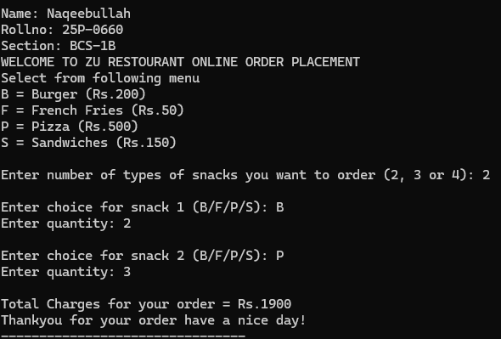
return 0;
}

QUESTION.NO.07:
#include <stdio.h>
#include <math.h>
int main() {
int acnt_no, mortgage;
float mortgageAmount, interestRate;
printf("Enter account number (-1 to end): ");
scanf("%d", &acnt_no);
if (acnt_no == -1) {
printf("Program ended");
return 0;
}
printf("Enter mortgage amount (in dollars): ");
scanf("%f", &mortgageAmount);
printf("Enter mortgage term (in years): ");
scanf("%d", &mortgage);
printf("Enter interest rate (as a decimal): ");
scanf("%f", &interestRate);
float totalInterest = mortgageAmount * interestRate * mortgage;
float totalPayable = mortgageAmount + totalInterest;
int months = mortgage * 12;
float monthlyPayment = totalPayable / months;
printf("The monthly payable interest is: $ %.0f\n", round(monthlyPayment));
return 0;
}

